I’ve been waiting for this for almost 9 years, and it’s finally here. Vault has a good splash screen!
Don’t get me wrong. The old splash screens were not bad, they just didn’t fit well with the product. Commonly the Vault screens would be very CAD related.
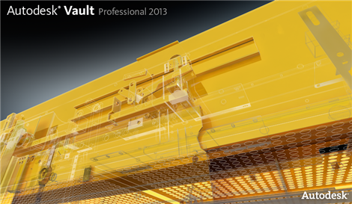
The above image would look perfect on AutoCAD or Inventor, but it just doesn’t fit Vault. It’s not a bad image, but it doesn’t describe what the product is about.

Some of the early releases of Vault used “guys standing around a table” imagery.
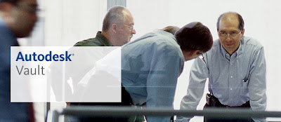
This is better, but it doesn’t quite hit the mark. Notice the lack of computers or anything hi-tech. Some of the images even featured people staring at blueprints. Although there is a collaboration aspect to Vault, it’s not really meant to simulate face-to-face meetings like what is being shown.

Vault is really about connecting and organizing CAD data, which brings us to the Vault 2014 splash screen.
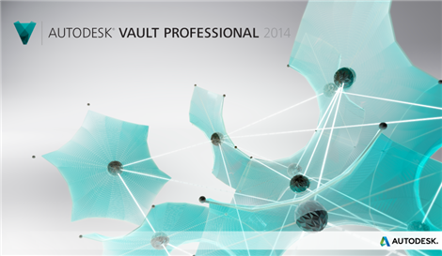
Ahh, look at it. A thing of beauty. It has a nice hi-tech vibe to it and is pleasing to the eye. So what do the interconnected balls represent? The vault client and server components? CAD files? People? Data management systems? The answer is all of the above. Vault does all of those things, and those things are a fitting description of Vault.
Vault is a hard product to describe, so it doesn’t surprise me that it took so long to get it right. I’m just glad it happened. As a programmer, I usually don’t care about things like branding, but it looks like some real effort was put in to understand the products. I’m not just talking about Vault either. All the new Autodesk product releases are accompanied by amazing imagery.

